CUSTOM BOOTCAMP
Azure Deployment/DevOps

DevOps
It is the union of people, process, and products to enable continuous delivery of value to end users.

OODA Loop: Observe, Orient, Decide, Act

Explore the DevOps Journey
- Continuous Integration (CI)
CI drives the ongoing merging and testing of code, which leads to finding defects early.

- Continuous Delivery (CD)
CD of software solutions to production and testing environments helps organizations quickly fix bugs and respond to ever-changing business requirements.

- Version Control
Version Control, usually with a Git-based repository, enables teams located anywhere in the world to communicate effectively during daily development activities.

- Agile/Lean:
  - Plan and isolate work into sprints.
  - Manage team capacity and help teams quickly adapt to changing business needs.
  - A DevOps Definition of Done (DOD) is working software collecting telemetry against the intended business goals.

- Monitoring and Logging
Monitoring and Logging of running applications.

- Cloud
Public and Hybrid Clouds have made the impossible easy.

- Infrastructure as CODE
Enables the automation and validation of the creation and teardown of environments to help with delivering secure and stable application hosting platforms.

- Microservices
Isolate business use cases into small reusable services that communicate via interface contracts.

- Containers
Containers are the next evolution in virtualization.

- DevOps may hurt at first.

Explore Agile Development Practices

- Waterfall Approach
- Define, analyze, build, and test, and deliver.
- Hard to accurately define requirements, which can change over time, including during development.
- Requires change requests and additional cost after delivery.

Advantages of waterfall model
- Easiest model to manage.
- Used with smaller size projects where requirements are easily understandable.
- Faster delivery of project.
- Process and results are well-documented. (Analyze Design Implementation)
- Easily adaptable method for shifting teams.
- This methodology is always beneficial to manage dependencies.

- Agile Approach
- Emphasizes constantly adaptive planning, and early delivery with continual improvement.
- Development methods are based on releases and iterations.
- At the end of each iteration, should have tested working code.
- Is focused on shorter-term outcomes.

Advantages of Agile Model
- It is focused client process.
- Agile teams are extremely motivated and self-organized so it likely to provide better result.
- Agile software development method assures that quality will be maintained.
- Incremental progress.

Choose the DevOps Tools

1. What is Azure DevOps?
- Azure Boards: Agile planning, work item tracking, visualization, and reporting tool.
- Azure Pipelines: A language, platform, and cloud agnostic CI/CD platform with support for containers or Kubernetes.
- Azure Repos: Provides cloud-hosted private git repos.
- Azure Artifacts: Provides integrated package management with support for Maven, npm, Python and NuGet package feds from public or private sources.
- Azure Test Plans: Provides an integrated planned and exploratory testing solution.

2. What is GitHub?
- Codespaces: Provide cloud-hosted collaborative development environments.
- Repos: Provide cloud-hosted and on=premises git repos for both public and private projects.
- Actions: Create automation workflows with environment variables and customized scripts.
- Packages: ease integration with numerous existing packages and open-source repositories.
- Security: Review code and identity vulnerabilities early in the development cycle.

Explore an Authorization and Access Strategy
- Azure DevOps Services uses wither a Microsoft account or Azure Active Directory, to protect and secure your data.
- For non-Microsoft tools like Git, NuGet or XCode you can use personal access tokens.
- Azure DevOps is pre-configured with default security groups and permissions.
- You can also configure app access policies and conditional access policies.

GitHub Project Boards
They are made up of issues, pull requests, and notes categorized as cards that you can drag and drop into your chosen columns.

GitHub Projects
They are a new, customizable, and flexible tool version of projects for planning and tracking work on GitHub.

Creating a Test_Project and Importing a git Repository in Azure Organization 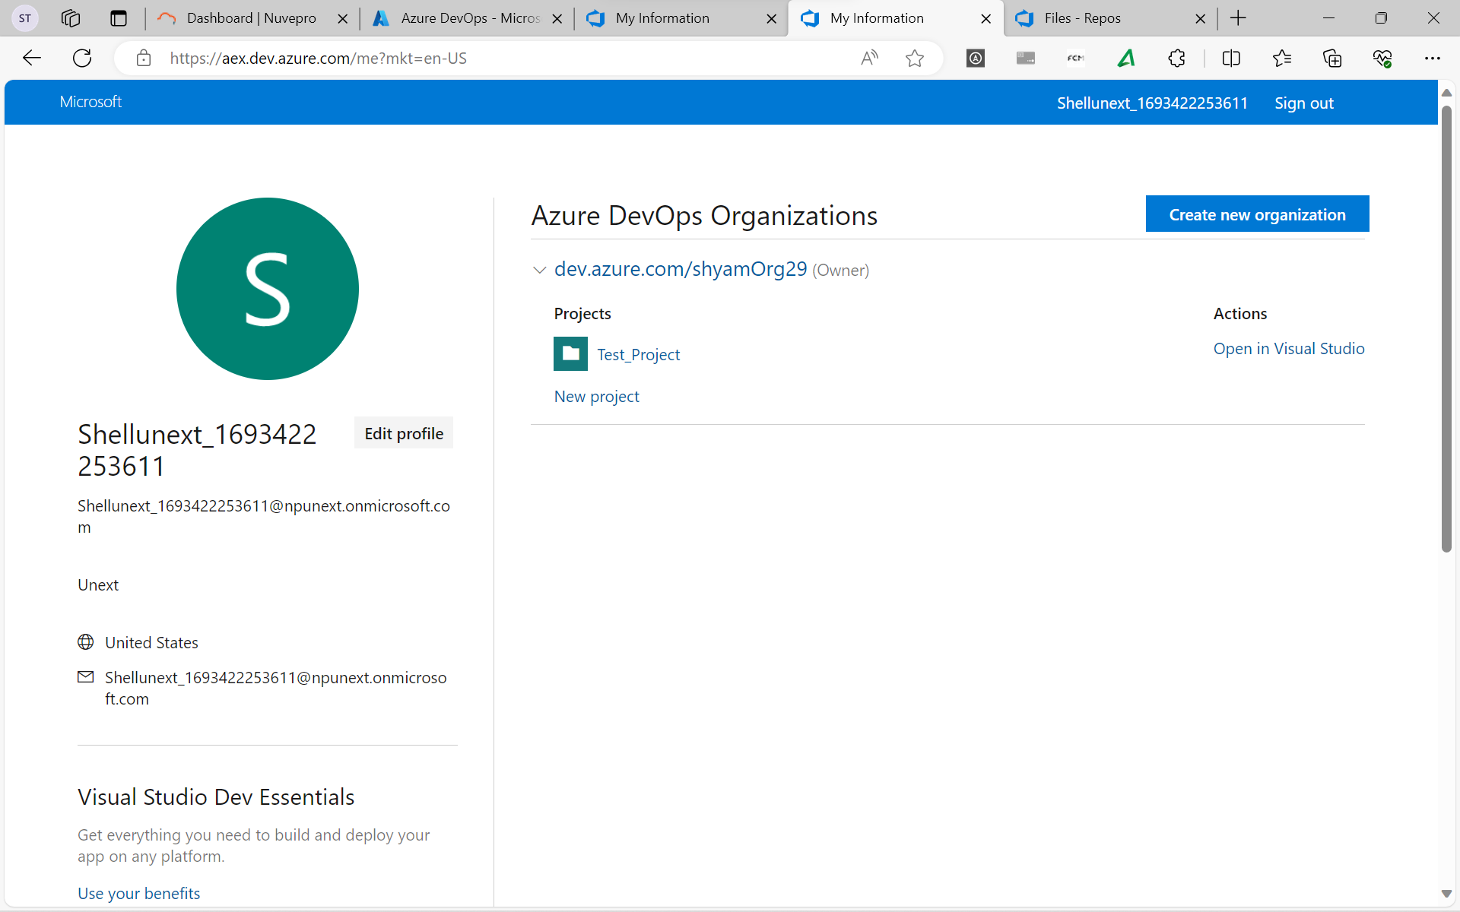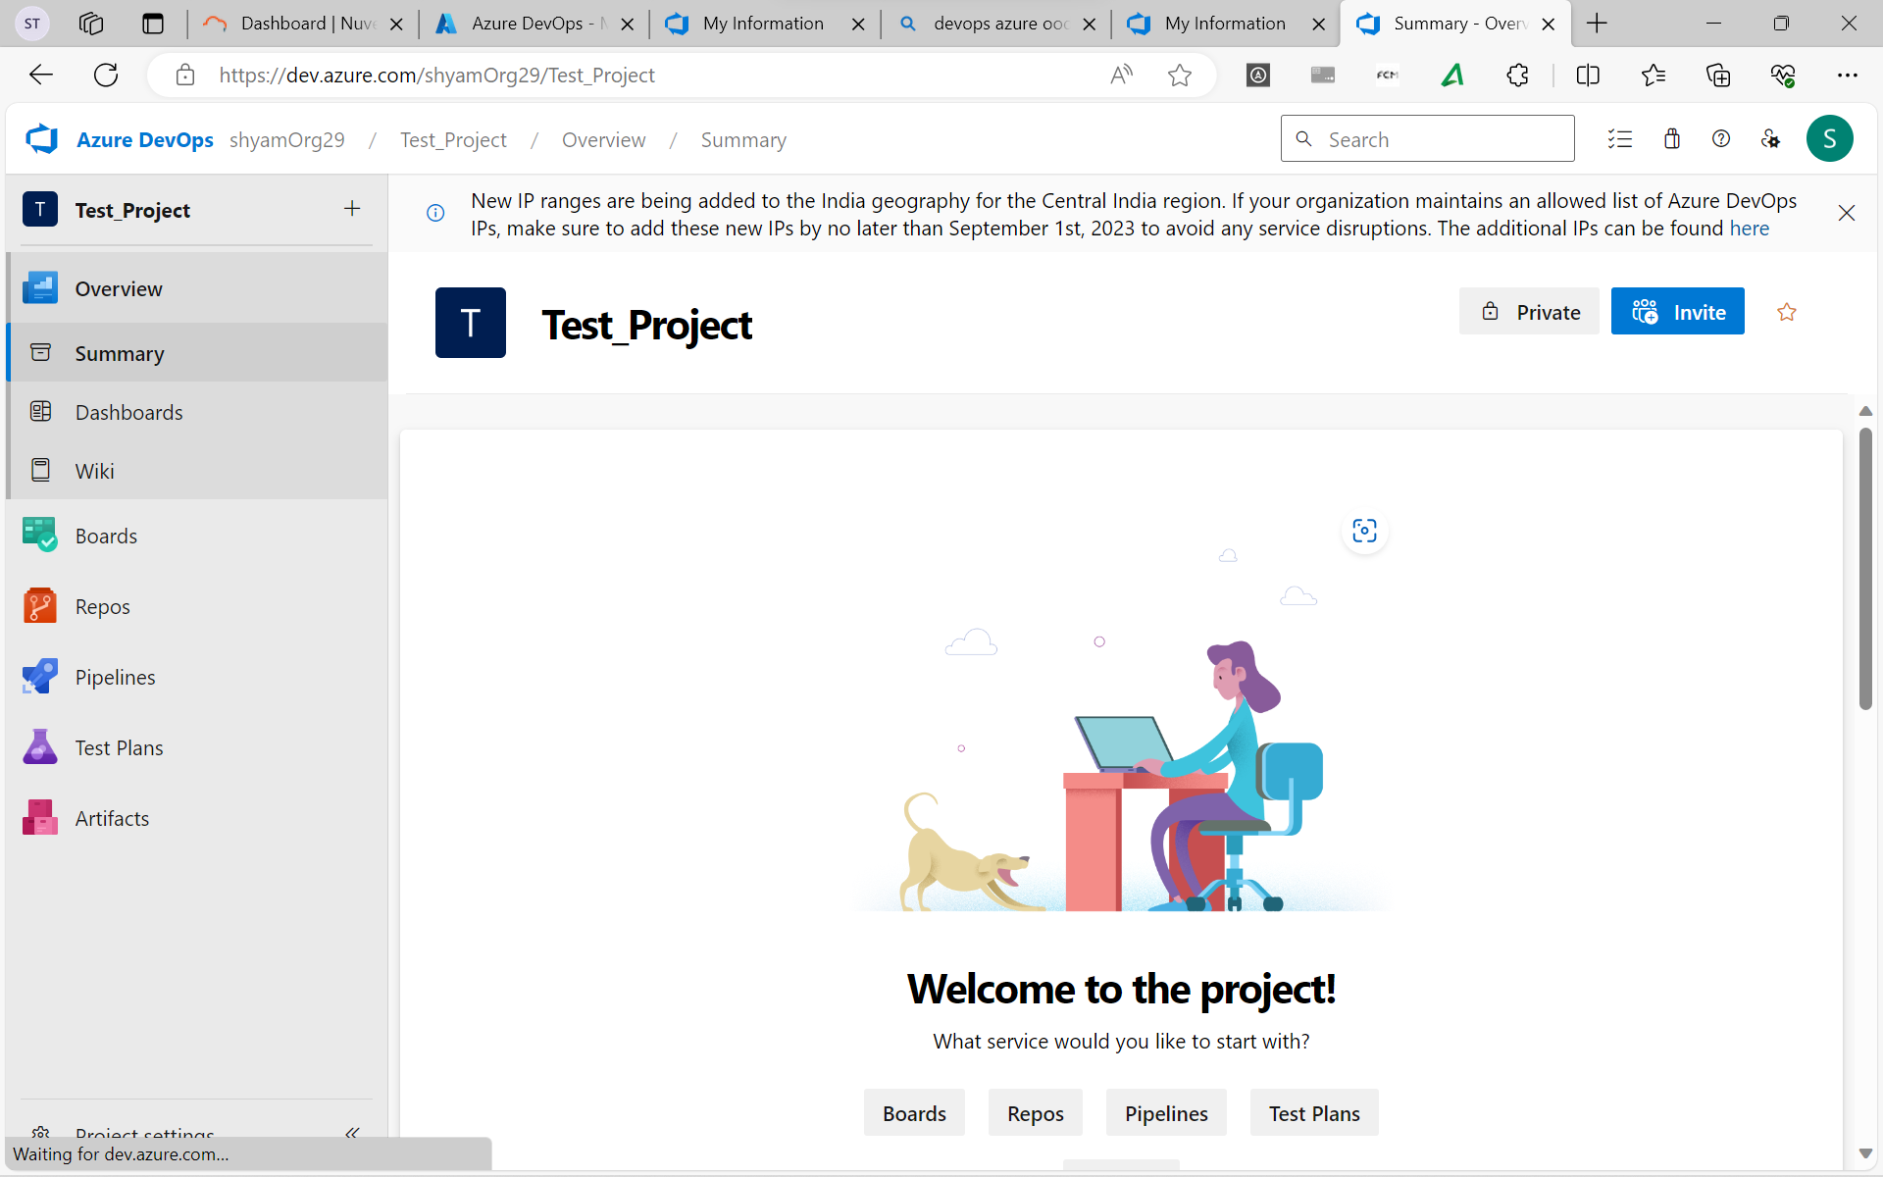 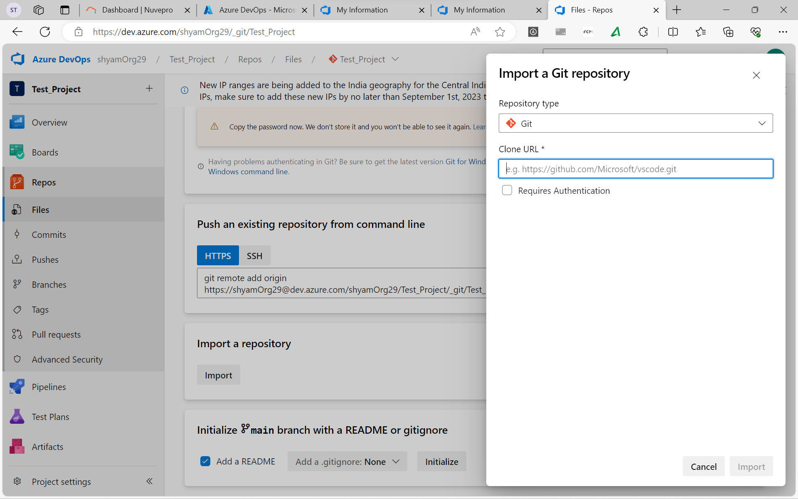Explore Monorepo versus Multiple Repos
- A repository is a place where the history of your work is stored.
- Azure DevOps projects can contain multiple repositories. There are always two philosophies on organizing your repos:
  - Monorepos: Source control paattern where all the source code is kept in a single repository
  - Multiple Repositories: Refer to organinzing your projects each into their separate repository.
- The fundamental difference betweent he monorepo and multiple repos philosphies boils down to a difference about what will allow teams working together on a system to go fastest.

Implement a Change Log

Manage Git Branches and Workflows

Enable Branch Workflow Types
- Feature Branching – All feature development should take place in a dedicated branch instead of the main branch.
- Forking Workflow – Every developer uses a server-side repository.
- Evaluate the Workflow

Enable Feature Branch Workflow
- Create a branch.
- Add Commits.
- Open a pull request.
- Discuss and review your code.
- Deploy
- Merge

Traditional IT Development Cycle
- Plan
- Realize
- Release
- Value

Eight Principles of Continuous Delivery
- The process for releasing/deploying software must be repeatable and reliable.
- Keep everything in source control.
- Everybody has responsibility for the release process.
- Automate everything.
- Done means “released.”
- Improve continuously.
- If something is difficult or painful, do it more often.
- Build quality in!

Create a Release Pipeline
Support pipelines as code (via YAML)
Most capabilities from classic release pipelines are available.

Explore Artifact Sources
- Build artifacts.
- Package repositories
- Container repositories
- Source Control

Choose the appropriate Artifact Source
- Traceability and Auditability
- Immutability
- Versioning

